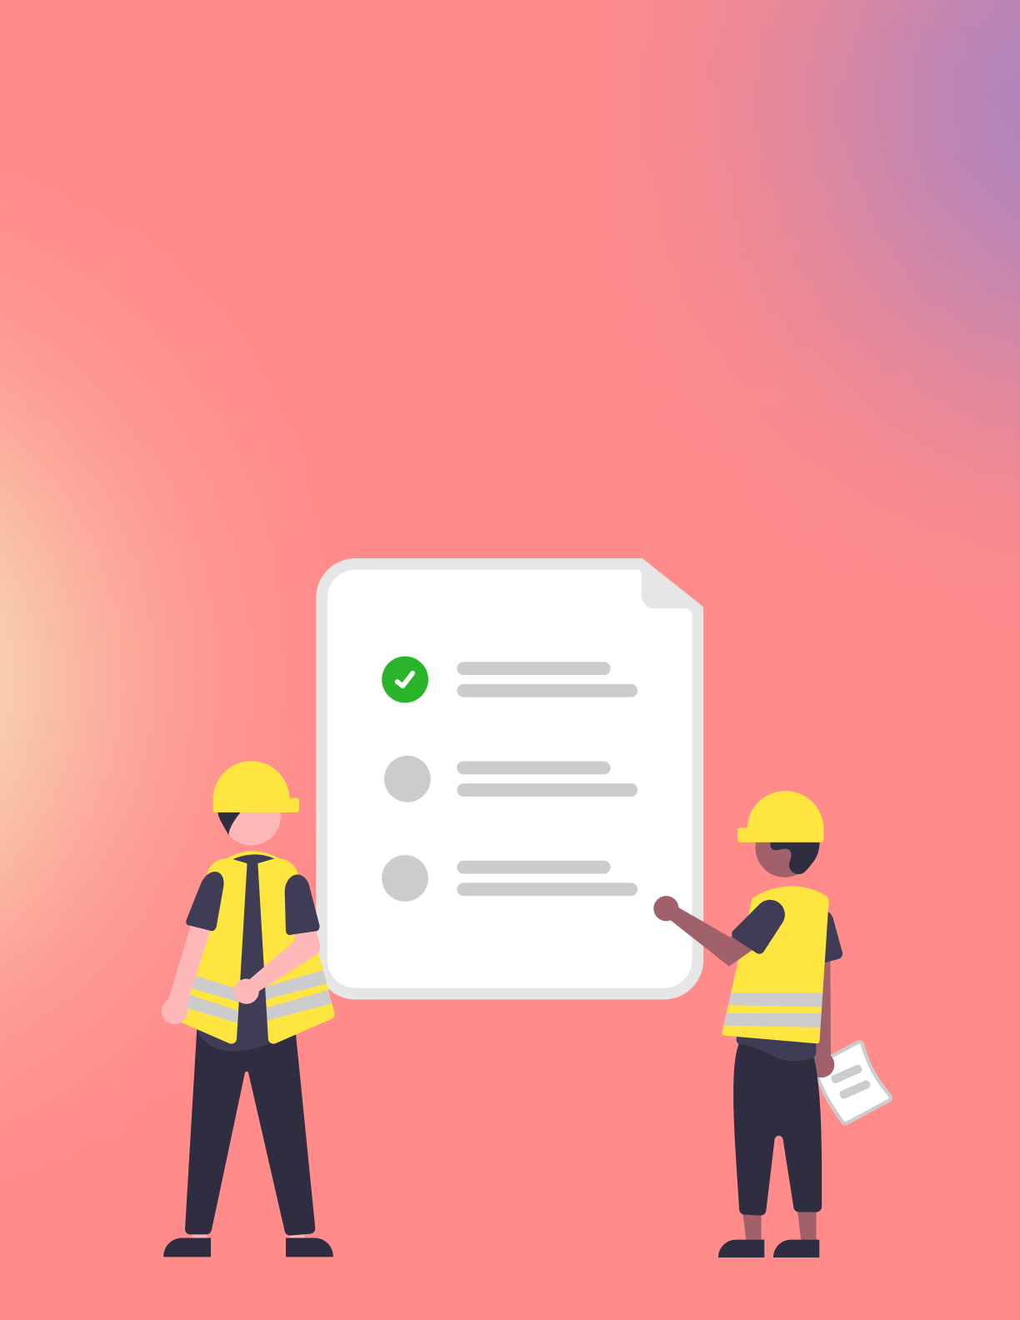
Safety INSPECTION
Checklist

Introduction:

Ensuring the safety of the workplace or equipment is a critical responsibility that can't be overlooked. This Safety Inspection Checklist serves as a guide to systematically inspect and evaluate safety protocols. Regular inspections can prevent accidents, encourage a culture of safety, and ensure compliance with industry standards.

Instructions:

- Complete this checklist during each designated inspection period.
- Fill in any identified issues in the notes section provided.
- If any item does not meet safety standards, address the issue immediately and document the corrective action in the notes section.

Inspection Details:

- Date of Inspection: {{Inspection_Date}}
- Location: {{Inspection_Location}}
- Inspector Name: {{Inspector_Name}}
- Supervisor Name: {{Supervisor_Name}}

Checklist Items:

- General Safety:

  - Are all safety signs visible and legible? {{Safety_Signs_Status}}
    - Notes: {{Safety_Signs_Notes}}
  - Are emergency exits clearly marked and unobstructed? {{Emergency_Exits_Status}}
    - Notes: {{Emergency_Exits_Notes}}

- Fire Safety:

  - Are fire extinguishers easily accessible and within service date? {{Fire_Extinguishers_Status}}
    - Notes: {{Fire_Extinguishers_Notes}}
  - Is the fire alarm system functional? {{Fire_Alarm_System_Status}}
    - Notes: {{Fire_Alarm_System_Notes}}

- Equipment Safety:

  - Are all machines serviced and maintained properly? {{Machines_Service_Status}}
    - Notes: {{Machines_Service_Notes}}
  - Are safety guards in place and functioning? {{Safety_Guards_Status}}
    - Notes: {{Safety_Guards_Notes}}

- Personal Protective Equipment (PPE):

  - Is PPE available and utilized by staff appropriately? {{PPE_Availability_Status}}
    - Notes: {{PPE_Availability_Notes}}
  - Are PPE storage areas organized and accessible? {{PPE_Storage_Status}}
    - Notes: {{PPE_Storage_Notes}}

- Hazardous Materials:

  - Are hazardous materials labeled and stored correctly? {{Hazardous_Materials_Label_Status}}
    - Notes: {{Hazardous_Materials_Notes}}
  - Are Material Safety Data Sheets (MSDS) available and up-to-date? {{MSDS_Availability_Status}}
    - Notes: {{MSDS_Availability_Notes}}

- Housekeeping:

  - Is the workplace clean and free of clutter? {{Workplace_Cleanliness_Status}}
    - Notes: {{Workplace_Cleanliness_Notes}}
  - Are waste disposal areas properly managed? {{Waste_Management_Status}}
    - Notes: {{Waste_Management_Notes}}

Concluding Remarks:

Overall Safety Compliance:
{{Overall_Compliance_Rating}}

Comments/Observations:
{{Inspection_Comments}}

Inspector Signature:  _________________________  Date:  _________________________ | Supervisor Acknowledgement:  _________________________  Date:  _________________________

Note: Retain a copy of this checklist for your records. Follow up on any corrective actions noted during the inspection promptly. Safety is everyone’s responsibility, and maintaining a secure environment is paramount for the well-being of all.

