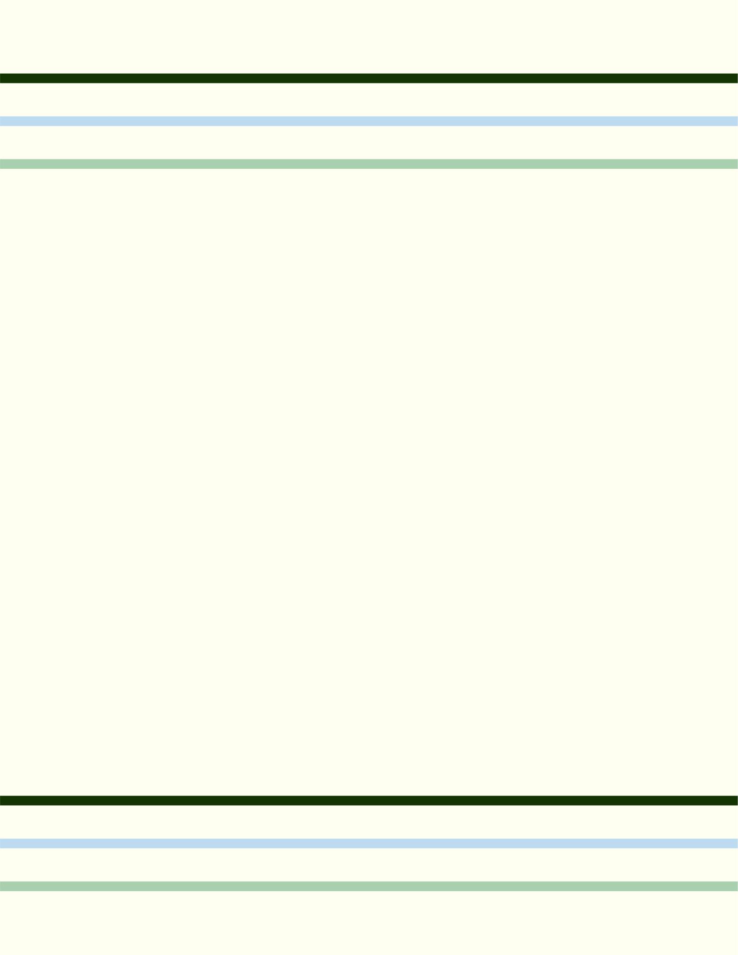

Business Name: {{Business_Name}} | Date: {{Date}}

BalanceSheet

Assets

Current Assets:

Item | Amount
Cash and Cash Equivalents | ${{Cash_and_Cash_Equivalents}}
Accounts Receivable | ${{Accounts_Receivable}}
Inventory | ${{Inventory}}
Prepaid Expenses | ${{Prepaid_Expenses}}
Other Current Assets | ${{Other_Current_Assets}}

Total Current Assets: ${{Total_Current_Assets}}

Non-Current Assets:
Item | Amount
Property, Plant, and Equipment | ${{Property_Plant_Equipment}}
Long-Term Investments | ${{Long_Term_Investments}}
Intangible Assets | ${{Intangible_Assets}}
Other Non-Current Assets | ${{Other_Non_Current_Assets}}

Total Non-Current Assets: ${{Total_Non_Current_Assets}}
Total Assets: ${{Total_Assets}}
Liabilities

Current Liabilities:

Item | Amount
Accounts Payable | ${{Accounts_Payable}}
Short-Term Debt | ${{Short_Term_Debt}}
Accrued Liabilities | ${{Accrued_Liabilities}}
Unearned Revenue | ${{Unearned_Revenue}}
Other Current Liabilities | ${{Other_Current_Liabilities}}

Total Current Liabilities: ${{Total_Current_Liabilities}}

Non-Current Liabilities:

Item | Amount
Long-Term Debt | ${{Long_Term_Debt}}
Deferred Tax Liabilities | ${{Deferred_Tax_Liabilities}}
Other Non-Current Liabilities | ${{Other_Non_Current_Liabilities}}

Total Non-Current Liabilities: ${{Total_Non_Current_Liabilities}}
Total Liabilities: ${{Total_Liabilities}}

Equity

Item | Amount
Common Stock | ${{Common_Stock}}
Retained Earnings | ${{Retained_Earnings}}
Other Equity | ${{Other_Equity}}

Total Equity: ${{Total_Equity}}
Total Liabilities and Equity: ${{Total_Liabilities_and_Equity}}

Please review and ensure all financial figures are accurate and up-to-date at the time of completing this balance sheet. This template aims to offer a clear and concise financial snapshot, aiding in strategic decision-making and financial analysis.

